**HACKERZDOM TUTORIALS**

**A PROJECT REPORT**

Submitted by

**HEMANT P HAREESH (Reg. No: BSARSCS009)**

**SIBIN MATHEW (Reg. No: BSARSCS030)**

**JOBY GEORGE (Reg. No: BSARSCS010)**

GUIDED BY

**Fr. Dr. JOHNY JOSE**

*(Asst. Prof., Department of Computer Science)*

**SUBMITTED IN PARTIAL FULFILLMENT OF THE**

**REQUIREMENT FOR THE DEGREE OF**

**BACHELOR OF COMPUTER SCIENCE**

**of**

**UNIVERSITY OF CALICUT**

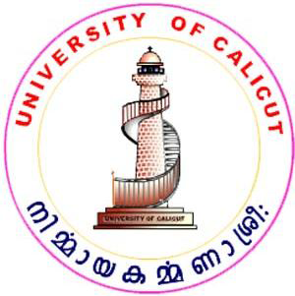 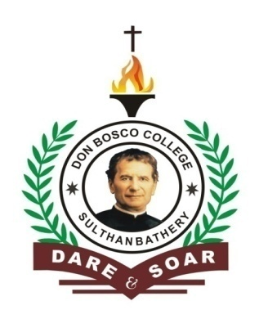

**DON BOSCO COLLEGE, SULTHAN BATHERY,**

**UNIVERSITY OF CALICUT**

**CALICUT**

**MARCH 2020**

**DON BOSCO COLLEGE**

**(A NAAC Accredited & ISO Certified Institution)**

**SULTHAN BATHERY, WAYANAD**

**(Affiliated to the University of Calicut)**

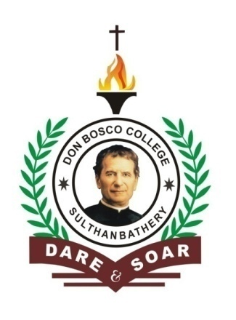

**CERTIFICATE**

This is to certify that the project report entitled “**HACKERZDOM TUTORIALS**” is a bonafide record of the work doneby **HEMANT P HAREESH (Reg. No: BSARSCS009), SIBIN MATHEW (Reg. No: BSARSCS030) and JOBY GEORGE (Reg. No: BSARSCS010)** in partial fulfillment of the requirements for the degree of Bachelor of computer science of Calicut University at **Don Bosco College, Sulthan Bathery.**

**Head of the Department Project Guide**

Submitted for the Project Viva Voice examination held on .....................

**Examiner1 Examiner2**

**DECLARATION**

We HEMANT P HAREESH, SIBIN MATHEW and JOBY GEORGE hereby declare that the project entitled **“HACKERZDOM TUTORIALS”** submitted to the Department of Computer Science, Don Bosco College, Sulthan Bathery, is a genuine record of the work done by us.

**Place: Sulthan Bathery** HEMANT P HAREESH

**Date:** SIBIN MATHEW

JOBY GEORGE

**ACKNOWLEDGEMENT**

We hereby dedicate this project to the Almighty God whose abundant grace and mercy enabled its successful completion, we would like to profound gratitude to all the people who have inspired and motivated us to make this project a success.

We would like to thank our parents and project guide who showed us the right way and gave us full support and help that made us confident to complete the project.

We express our gratitude to Rev. Fr. Dr. Joy Ullattil (Principal of Don Bosco College), Fr. Sojan Panachikkal (Vice Principal), Ms. Sritha S (HOD of Computer science Department) and Fr. Dr. Johny Jose, our project guide for his encouragement and expert guidance throughout the project period.

We are thankful to all the faculty members of Department of Computer Science, Don Bosco College for their inspiration and encouragement shown to us throughout the course. We also express our gratitude to all our instructors of various other departments and to the office staff and all other supporting staff of Don Bosco College.

We would like to extend our sincere thanks to our classmates without whose support and encouragement this project would not have attained its perfection in its total. Finally we convey our thanks to all who helped us directly and indirectly to carry out this final year project successfully.